
FACULTY OF TECHNOLOGY AND ENGINEERING
DEVANG PATEL INSTITUTE OF ADVANCE TECHNOLOGY
AND RESEARCH
DEPARTMENT OF COMPUTER ENGINEERING
A.Y 2026 – 27 Semester – 3
LAB MANUAL

CSUC201 Fundamentals of Data Structures and Algorithms

Practical 2: Linear and Binary Search: Iterative and Recursive
Approaches
Practical Aim
Problem 1
A security guard at a parking lot checks vehicles one by one from the entrance to find a car with
a specific license plate. Sometimes he starts from the entrance, sometimes he calls a helper
who starts from where the guard left off. Given a list of license plates and a target plate,
implement both approaches — one that checks plates one by one from the start, and one where
the function calls itself to continue checking — and report the position of the target plate if
found.
Code:
Git hub link:
https://github.com/25DCS032/DSA-25dcs032
Out put screenshot:
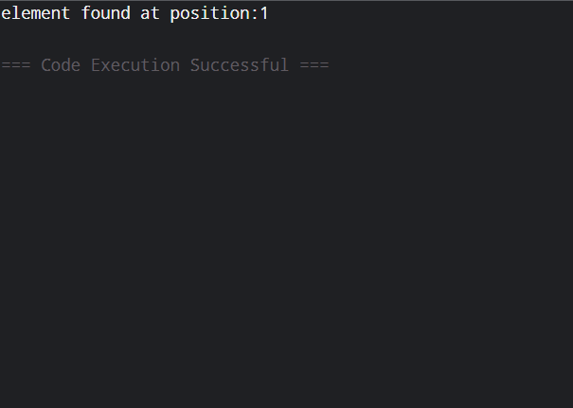
Problem 2
A librarian maintains a sorted catalog of book codes and needs to locate a specific code quickly.
Instead of going through every book, she opens the catalog to the middle, checks whether the
target is to the left or right, and repeats. Given a sorted list of book codes and a target code,
implement both approaches — one using a loop and one where the function calls itself — and
report the position of the target code.
Code:
Git hub link:
25dce103_DSA_PJP_3CE2_B/Practical-2 at main · nidhisavalia/25dce103_DSA_PJP_3CE2_B
Out put screenshot:
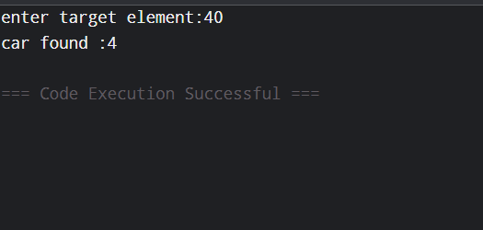
Challenges Faced:
base condition in recursive search.

Out comes:
linear search and binary search using iterative and recursive methods.
1. If the target plate appears near the end of a very long list, your solution still checks every plate before it. Can you think of any property the input would need to have for you to skip checking some plates entirely? What does Problem 2.2 tell you about
this?
Ans: Linear search checks elements one by one. If the data is sorted, binary search can skip half the elements each time, making searching faster.
2. What is the consequence of applying your solution to a list that is not
sorted? Would it always give a wrong answer, or only sometimes? Explain your
reasoning without running any example.
Ans:
Binary search requires the list to be sorted. If it is unsorted, it may give an incorrect result or fail to find an existing element.

